1. Project Goals:
2. Customer Sentiment Analysis: Perform sentiment analysis on customer interactions. Identify positive, negative, and neutral sentiments expressed by customers to understand overall satisfaction levels.

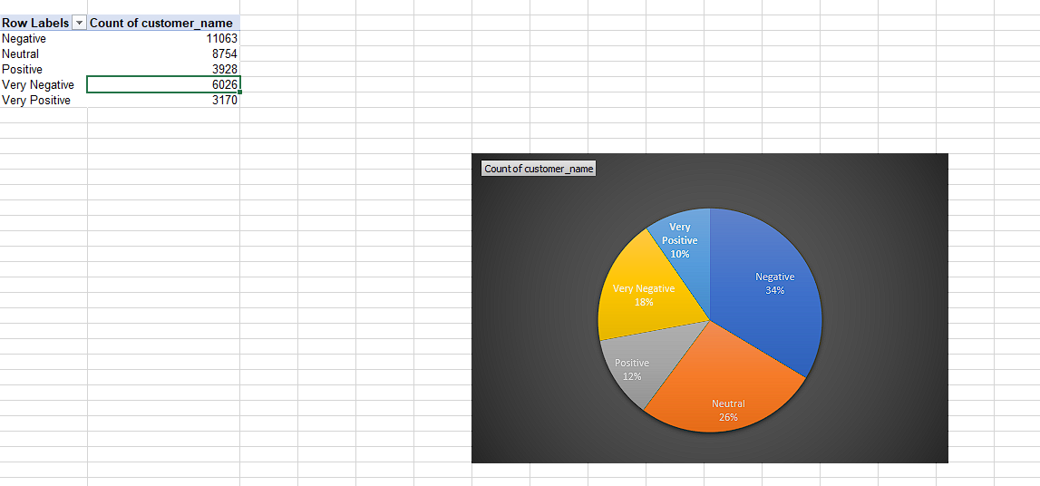

1. Root Cause Analysis: Investigate common customer complaints. Pinpoint recurring problems to address them proactively and prevent future escalations.   
   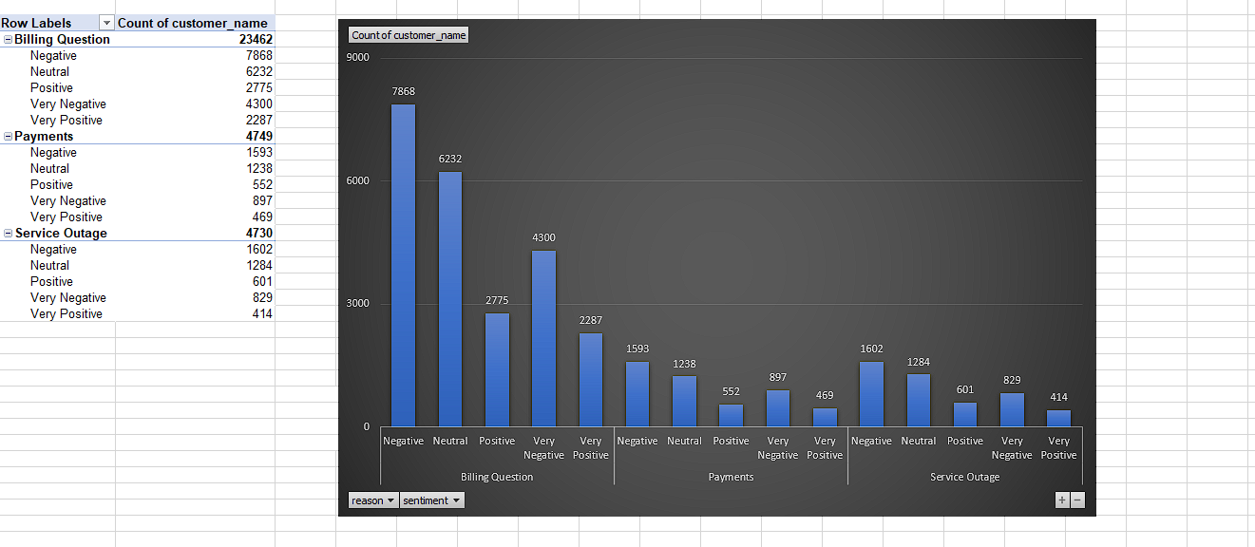
2. Service Response Time Analysis: Analyze response times for customer queries and support requests to assess the efficiency of the customer service team.

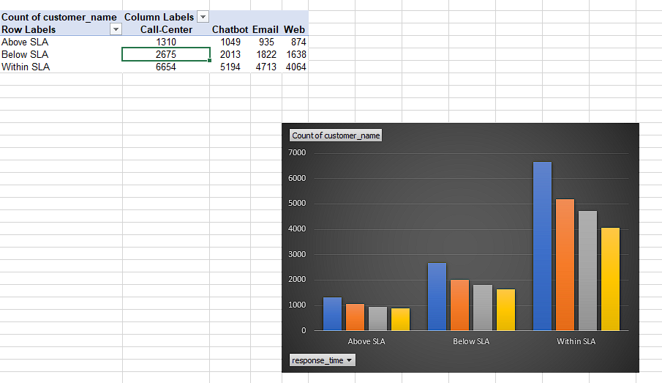

1. Customer Segmentation: Segment customers based on their demographics, behaviour, and preferences. Understand different customer segments' needs and pain points to tailor services and communications accordingly.

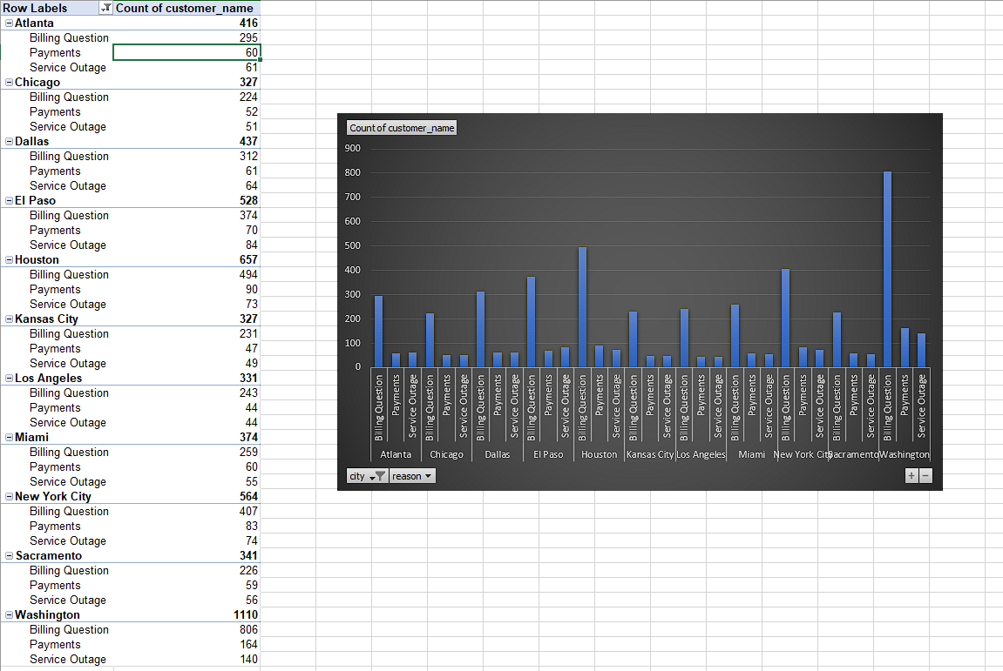

1. Trends and Patterns Identification: Identify patterns and trends in customer service data to uncover opportunities for process improvements and innovative service offerings.

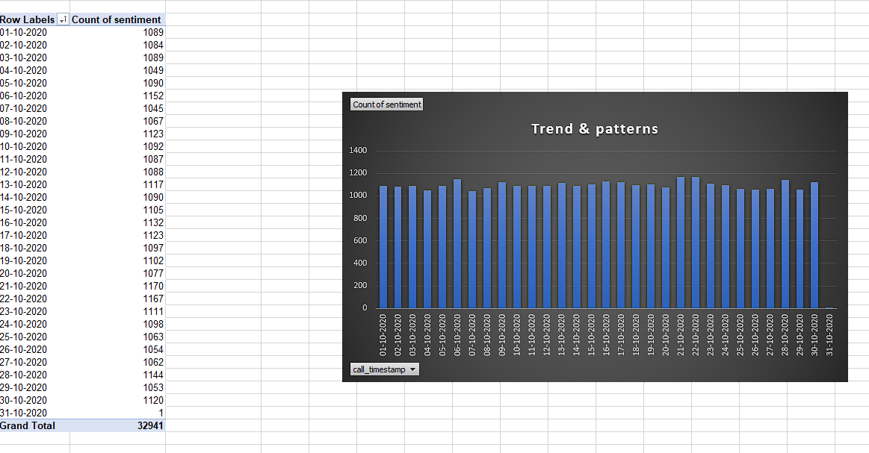

1. Final Report

